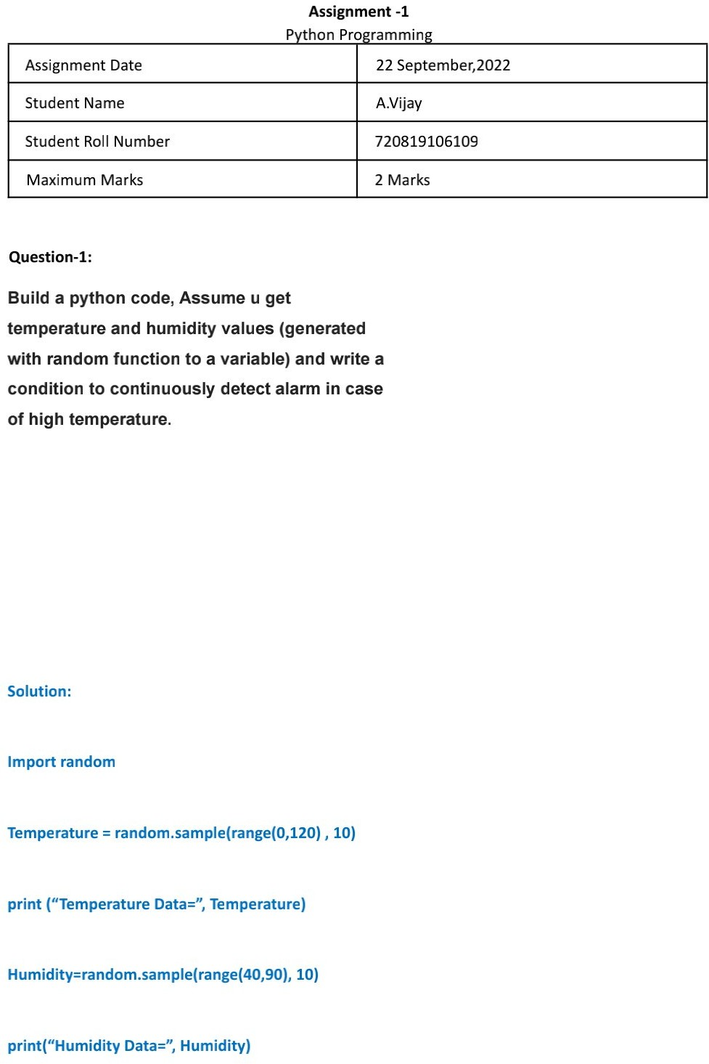

M Venkata Pavan Kumar

**Assignment - 2**

2 Marks

110719106019

M pavan kumar

22 September,2022

